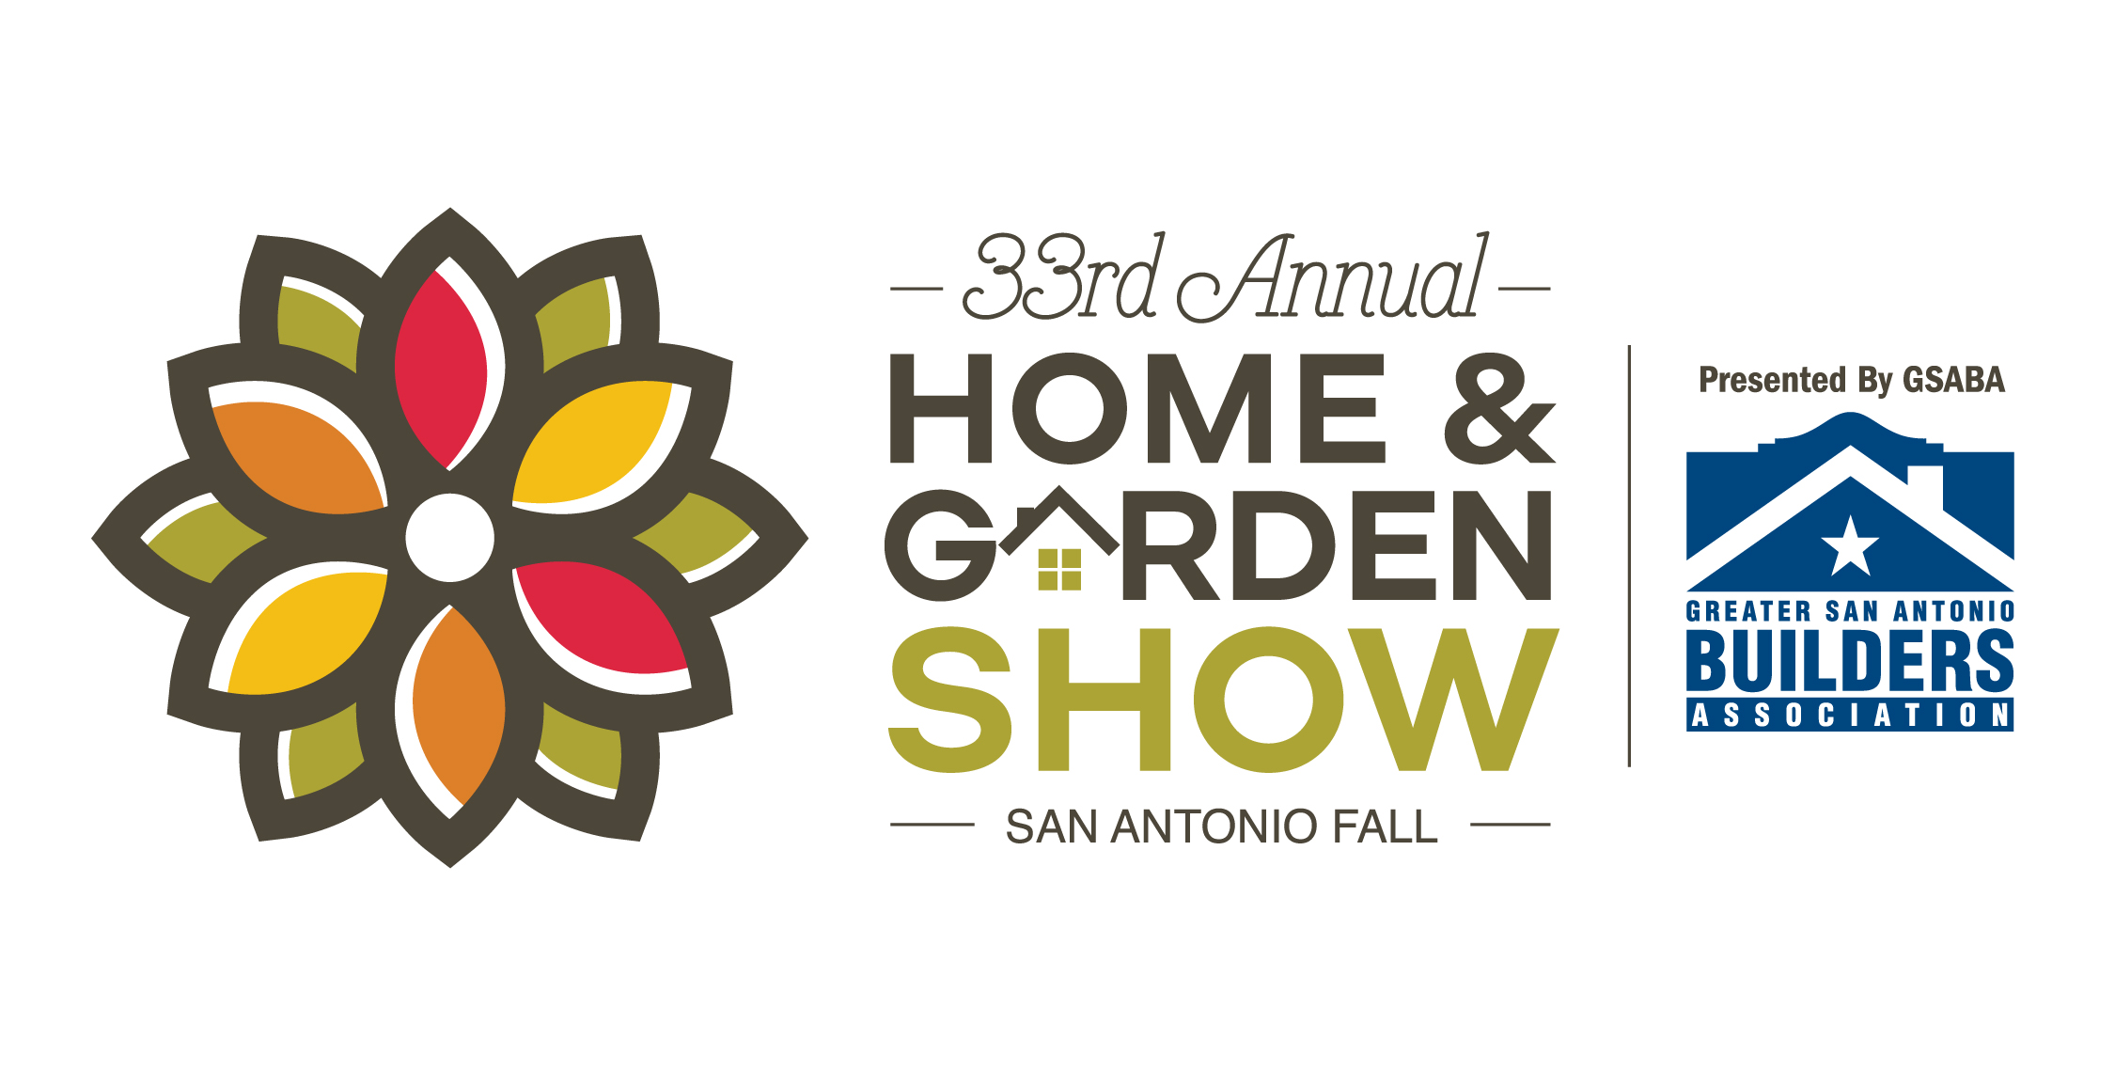

**EXHIBITOR MANUAL**

**THE ALAMODOME**

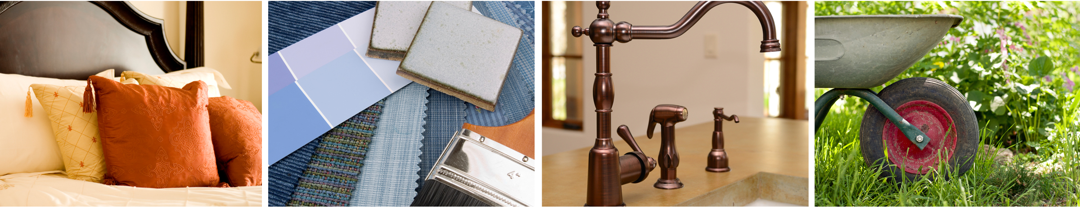

**September 27-29, 2019**

This Exhibitor Manual has been compiled to help you and your staff with complete details about all phases of the exhibition process at the San Antonio Fall Home & Garden Show.

Enclosed you will find helpful information to make your participation in our show successful.

**We strongly urge that you give this manual to those having responsibility for your participation in the show.**

**SanAntonioFallHomeShow.com**



**SHOW MANAGEMENT**

**The San Antonio Fall Home & Garden Show is produced and managed by:**

**Marketplace Events**

12800 N Meridian St. Ste 135 |Carmel, IN 46032

Amanda Nelson, Show Manager

P: 512.368.6751

AmandaN@mpeshows.com

**___________________________________________________________________________________**

**SHOW TEAM**

Laura Martin Exhibit Sales Consultant | LauraM@mpeshows.com

Dana Gutierrez Show | Office Administrator | DanaG@mpeshows.com

**___________________________________________________________________________________**

**SHOW FACILITY**

**The San Antonio Fall Home & Garden Show is held at:**

**The Alamodome**

100 Montana St.

San Antonio, TX 78203

P: 210.207.3663

**___________________________________________________________________________________**

**SHOW DECORATOR**

**Booth Furnishings: rental of tables, chairs, booth carpeting, signs, & labor**

**GEMS**

3276 Quebec St.

Dallas, TX 75247

P: 214.388.5722

F: 214.388.5442

**_____________________________________________________________________________________**

**UTILITIES**

**Telephone, Internet & Electricity**

* Electricity will be provided by FREEMAN.

(Please see Electricity kit on our show site for details)

**PHONE**: 1.800.423.8416 **WEBSITE**: [www.freeman.com](http://www.freeman.com)

* WIFI will be provided by The Alamodome free of charge.

Phone/Internet hardlines are also available through The Alamodome for a fee of $250.00

**PHONE**: 210.207.3663 **WEBSITE**: [www.alamodome.com](http://www.alamodome.com)

**_______________________________________________________________________________________**

**MOVE-IN | MOVE-OUT DAYS AND HOURS**

**MOVE-IN DAYS AND HOURS**

|  |  |  |
| --- | --- | --- |
| Tuesday | September 24th, 2019 | 11AM – 6PM |
| Wednesday | September 25th, 2019 | 9AM – 7PM |
| Thursday | September 26th, 2019 | 9AM – 2PM  2PM – 7PM  **(NO Drive In Permitted)** |
| Friday (Hand carry ONLY) | September 27th, 2019 | 9AM – 1PM |

Exhibitors requiring forklift service should make arrangements with the Show Decorator prior to move in. Call GEMS at 214-388-5722 for verification of the rate for your particular need and any other questions.

Move-in must be completed by 1:00pm on Friday, September 27th.

Make sure to clear all trash, boxes, crates, etc. from the aisles prior to the beginning of the show.

**If you need additional time, please make special arrangements with Show Management.**

**MOVE-OUT DAYS AND HOURS**

|  |  |  |
| --- | --- | --- |
| Sunday | September 29, 2019 | 6PM – 9PM |
| Monday | September 30, 2019 | 8AM – 1PM |

***NO EXHIBIT CAN BE REMOVED, EVEN IN PART, UNTIL IT IS ANNOUNCED OVER THE PUBLIC ADDRESS SYSTEM THAT IT IS PERMISSIBLE, LISTEN FOR THE ANNOUNCEMENT - IT WILL BE LOUD AND CLEAR!***

Aisle carpet will be removed on Sunday night immediately after closing. After aisles are clear of carpet, vehicles may enter the building for loading of heavy items, as long as there is a pathway for access.

**During Move-Out everything that your company brought to the Show must be removed or disposed of after the Show. If not, there will be a charge to your company for cleanup. Any damage to the facility floor will be charged to your company.**

**SHOW HOURS**

|  |  |  |
| --- | --- | --- |
| Friday | September 27, 2019 | 2:00pm – 7:00pm |
| Saturday | September 28, 2019 | 10:00am – 7:00pm |
| Sunday | September 29, 2019 | 11:00am – 6:00pm |

**\*You must man your booth each day from show open to show close. Leaving early is a violation of your signed contract.**

**ACCOUNT BALANCES**

Final payment for exhibit space must be made by ***August 12, 2019.*** Show management reserves the right to refuse entry to any exhibitor whose account has not been paid in full. **Badges and complimentary tickets will not be available until the account has been paid in full.**

**__________________________________________________________________________________________**

**PARKING**

Parking passes can be bought through The Alamodome. In/ out privilege parking may be bought in advanced.

Debit, credit cards, and cash are all accepted for payment.

**__________________________________________________________________________________________**

**EXHIBITOR BADGES**

Exhibitor badges are required to identify yourself as an authorized exhibitor. Exhibitors will not be allowed access during show days without a badge. Exhibitor badges are not required during move-in.

Five (5) exhibitor badges are provided for 100 square feet of space or smaller.

Ten (10) exhibitor badges are provided for 200 – 300 square feet of space.

Fifteen (15) exhibitor badges are provided for 301 square feet or larger

You are encouraged to drop off your badge each night in the Show Office, so that your company does not run out of badges.

**EXHIBITOR BADGES MAY NOT BE USED AS ADMISSION TICKETS**.

**__________________________________________________________________________________________**

**COMPLIMENTARY TICKETS**

Ten (10) complimentary tickets are provided for 200 square feet of space or smaller.

Twenty (20) complimentary tickets are provided for 201 square feet of space or larger.

If you need additional tickets, these can be purchased at half price for $5 each prior to the show or at the show office any time during the show.

**COMPLIMENTARY TICKETS ARE NOT PERMITTED TO BE DISTRIBUTED AT THE ENTRANCE TO THE SHOW**. Use your tickets to invite potential customers to the show, as a thank you to good customers and for friends and family.

**__________________________________________________________________________________________**

**SHOW OFFICE**

Our show office will open on Tuesday, September 24th at 10am. When you arrive to move-in, please check in and pick up your exhibitor packet. The Show Office will remain open through the end of the Show, on Sunday, September 29th.

**__________________________________________________________________________________________**

**WILL CALL**

Will Call will be located at the box office.

Please leave your tickets in INDIVIDUALLY marked envelopes with FIRST AND LAST NAME for your guests.

**EXHIBITOR BADGES ARE FOR EXHIBITORS, THEY ARE NOT TICKETS TO THE SHOW. THEY SHOULD NOT BE LEFT AT WILL CALL TO BE PICKED UP BY ATTENDEES. THEY MAY ONLY BE LEFT FOR PEOPLE WORKING YOUR BOOTH.**

**________________________________________________________________________________________**

**DECORATOR SERVICES**

GEMS is the show decorator and provides carpet, tables, chairs, cleaning, signage etc. Please order directly with them.

**__________________________________________________________________________________________**

**FLOORING**

Flooring is not included in the cost of your exhibit booth. **It is mandatory that all exhibit booths are carpeted or have some type of clean, professional-looking floor covering that covers 100% of the booth’s square footage.** Carpeting, Astroturf, hardwood, tile, vinyl flooring etc., may be used.

Visqueen must be placed on the floor before laying bricks, patios, mulch, etc. Do not drill holes, paint, nail glue or affix flooring to the Fairgrounds flooring. **Any damage to the flooring will be repaired at the exhibitor's expense.**

**__________________________________________________________________________________________**

**TABLE COVERINGS**

It is mandatory that all tables are properly skirted. Skirting must go from the edge of the table to the floor on all VISIBLE sides. All skirting must be pressed and neat. **Use of plastic table cloths, sheets, shower curtains or any type of “makeshift” table cloths is not permitted**. We strictly enforce this and will skirt all incorrectly skirted tables at the exhibitor’s expense.

All inventory and personal items must be stored COMPLETELY OUT OF SIGHT. Your booth should look professional and inviting to the attendee.

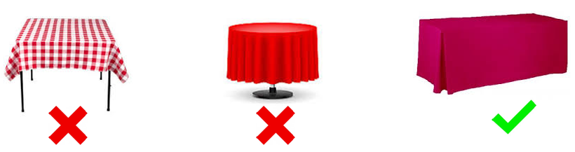

**__________________________________________________________________________________________**

**VEHICLES IN EXHIBITS**

If you plan on having a vehicle in your booth as part of your display, please contact Show Management for approval and move-in instructions. All vehicles, boats and equipment containing fuel must meet and comply with the following requirements before entry into the facility:

a. There is to be no more than five (5) gallons of fuel or ¼ the capacity of the fuel tank, whichever is less.

b. Fuel tanks used for storage of excess fuel must meet applicable Federal, State and Local fuel storage

requirements.

c. Fuel tanks are to be locked and all portable tanks removed. Locking the vehicle will be sufficient for cars in which

the gas cap cover can only be detached from inside the vehicle.

d. Ignition keys are to be removed and paced in a central location on-site.

e. Vehicles, boats and similar exhibited products with more than hundred square feet (100 sq. ft.) of roofed area are to

have a smoke detector.

**__________________________________________________________________________________________**

**BOOTH INFORMATION, RULES & REGULATIONS**

Exhibit booths will have an 8' draped back wall. On each side, a draped side rail will extend from the back of the booth to the front of the booth at a height of 3’.

Drape color: **Black**

Aisle carpet is **Tuxedo for Main Aisles Only**

**Staffing Your Booth**

All exhibitors are expected to be in their booths during all published show hours, as we do receive consumer complaints about un-manned displays. Our visitors pay an entrance fee and expect to be able to do business with our exhibitors at any time during show hours. If you are in violation of this rule, your company may not be permitted to exhibit with us in the future.

**Demonstrations and handouts**

Exhibitors demonstrating products and/or distributing marketing materials, product samples or souvenirs are not permitted to do outside the confines of their rented exhibit area. Working in the aisle is strictly prohibited and will be enforced by show management. This includes any mascots.

**ALL FOOD SAMPLING MUST BE APPROVED BY SHOW MANAGEMENT, VENUE, & HEALTH DEPARTMENT**

**Booth Guidelines**

MPE provides each inline exhibitor with a back curtain 8 feet in height, two side curtains, each 3 feet in height and an ID sign with company name and booth number. A corner booth has only back drape. An island booth, opens on all sides, does not have any pipe and drape or ID sign.

Inline booth displays, including signage, shall not exceed 8 feet in height. Signs exceeding booth height requirements must be approved by show management or exhibitor may be asked to remove. Your display may be 8 feet high for the width of your back drape (this only applies to inline spaces). On each side you will have a 3 feet high side curtain. For inline spaces, your display may remain 8 feet in height from the back wall, up to 5 feet from the aisle, or ½ the depth of your booth. For the remaining 5 feet, your display must return to the same 3 feet height of the side curtain. No pop-up tents allowed unless in an island booth. All flag banners must meet sight guidelines.

All unfinished portions of displays must be draped or finished to be pleasant to the public view. Show Management may require exhibitors to purchase drape if display is not finished adequately. **Your own flooring is REQUIRED.**

If your exhibit space is a peninsula, special restrictions may apply as indicated by your sales representative.

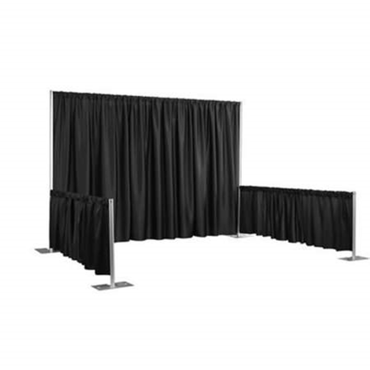

**8’ high x 10’ wide x 3’ front to back sides**

**Telephone, Internet & Electricity**

* Electricity is provided by Freeman Electric (Please see Electricity Kit on show website for details)

**PHONE**: 1.800.423.8416 **WEBSITE**: [www.freeman.com](http://www.freeman.com)

* The Alamodome will provide Wifi free of charge and a phone hardline may be purchased for $250.00.

**PHONE**: 210.207.3663 **WEBSITE**: [www.alamodome.com](http://www.alamodome.com)

**Microphone, Audio Equipment & Music**

Use of microphones, audio equipment and musical instruments is permitted, however, sound levels must be kept at a volume that management deems reasonable. Violators will receive one warning. If there are more problems with volume, Show Management reserves the right to prohibit the exhibitor from using sound equipment for the remainder of the show.

**Music, Photographs & Other Copyrighted Materials**

Each exhibitor is responsible for obtaining all necessary licenses and permits to use music, photographs or other copyrighted material in exhibitor's booth or display. No exhibitor will be permitted to play, broadcast or have performed any music or use any other copyrighted material, such as photographs or other artistic works, without first presenting to Marketplace Events proof that the exhibitor has, or does not need, a license to use such music or copyrighted material. Marketplace Events reserves the right to remove from the exhibit all or any part of any booth or display which incorporates music, photographs or other copyrighted material and for which the exhibitor fails to produce proof that the exhibitor holds all required licenses. The exhibitor shall remain liable for all claims, causes of action, suits, damages, liability, expenses and costs, including reasonable attorney's fees, arising from or out of any violation of infringement (or claimed violation or infringement) by exhibitor, exhibitor's age or employees of any patent, copyright or trade secret rights or privileges.

**_____________________________________________________________________________________**

**SECURITY**

Show Management provides security for the show floor during move-in, move-out, show hours and overnight. However, neither Show Management nor the Alamodome is responsible for lost, damaged or stolen articles. We encourage you to take all valuables with you when the show closes each evening. A tarp/sheet covering your booth after show hours goes a long way in securing your belongings.

Most thefts happen during move-in, move-out and within 30 minutes of show closing. Staff your booth accordingly and when the show does close, wait for the attendees to clear out.

**Report anything of a suspicious nature to Show Management and/or Security.** Leads can be followed up to avoid incidents of theft.

**Ensure you are adequately insured.**

**__________________________________________________________________________________________INSURANCE**

Show Management is insured against public liability and property damage claims arising out of the conduct of the show. This insurance does not cover exhibitors’ property, which is placed on display at the exhibitor’s risk. Every reasonable precaution will be taken to protect exhibitors’ properties, but Show Management assumes no responsibility for any losses due to fire, theft, robbery, damage, accident or other causes. Please refer to items #4 and 5 on your exhibitor contract/application or contact Show Management if you have questions.

**__________________________________________________________________________________________**

**SHIPPING INFORMATION**

All shipments must go through GEMS, please contact them for pricing on handling shipments.

|  |
| --- |
| **Direct Shipment Address**  **Cannot be delivered prior to September 24th, 2019** |
| **The Alamodome**  **c/o GEMS**  **[Exhibiting Co. Name & Booth #]**  **Home & Garden Show**  **100 Montana St.**  **San Antonio, TX 78203** |

**All shipments must be prepaid and should be clearly marked with your company name, booth number and** **Building Name**. Special arrangements may be made with GEMS on items that need special care. Shipping items to the venue, may incur additional charges.

**Show Management is not responsible for your packages; please do not send packages before your arrival as you MUST be present to sign for them.**

Please make arrangements to dispose of or store shipping crates with the show decorator.

**__________________________________________________________________________________________**

**BUILDING REGULATIONS**

**Smoking Regulations**

No smoking is permitted inside any building at the Alamodome.

**Alcohol/Drugs Regulations**

No alcohol may be consumed on show site other than during designated times and locations as specified in this Exhibitor Service Manual and/or on posted signage by the show facility. Alcohol consumption is strictly forbidden during all move-in and move-out hours.   Additionally, the use or distribution of illegal drugs is strictly forbidden.  Any persons including exhibitors, service providers, employees, attendees or anyone else working at or attending the show that does not comply with this policy will be removed from the show and their credentials will be revoked.

**Sale of Merchandise at the Show**

All Exhibitors are reminded that to sell products "cash and carry" during the show, you must comply with all rules and regulations of Marketplace Events. Exhibitors are responsible for obtaining any such permits as required. Only merchandise approved by the show may be sold. No food or drinks may be sold without the approval of show management and The Alamodome.

**Animals/Pets**

Service animals are allowed inside the building during event hours of the event**. Personal pets are not allowed unless preauthorized by show management.**

**Helium items**

No exhibitor will be permitted on the roof of the building for the purpose of installing aerials or for any other reason.

**NO HELIUM, PROPANE OR GAS CONTAINERS ARE ALLOWED BY ORDER OF THE ALAMODOME. HELIUM FILLED BALLOONS ARE NOT ALLOWED TO BE GIVEN OUT TO VISITORS OR BE APART OF YOUR DISPLAY.**

**Fire Regulations**

No flammable products, open flames, or flammable display materials, etc. are permitted in the exposition hall by order of the Fire Department and the Facility Security Department. Enclosed structures under 300 sq.ft. must have a fire extinguisher and smoke detector. Enclosed structures of over 300 sq.ft. must install a sprinkler system inside the structure. No cartons, boxes, or crates may be stored behind booth curtains. Pine straw is not allowed unless treated.

All material used in the construction and decoration of an exhibit must be flame retardant. This includes scenery, backdrops, drapes, table and dust covers.

No hazardous material will be permitted in an exhibit.

No vehicles or other apparatus, which has a fuel tank, will be permitted as a display without written permission from show management.

**THE FIRE MARSHALL OF THE STATE OF TEXAS RESERVES THE RIGHT TO MAKE ANY FINAL DECISION REGARDING THE ABOVE REQUIREMENTS**